Why to use SimplyClip?

* **Tired of filling the repetitive forms? SimplyClip is here for you!**

Forms require a lot of data to be filled in, and tasks can get busy if you have to fill out multiple forms, such as student applications. SimplyClip allows you to copy all the data you need multiple times so you can paste it when you need it, without having to retype it.

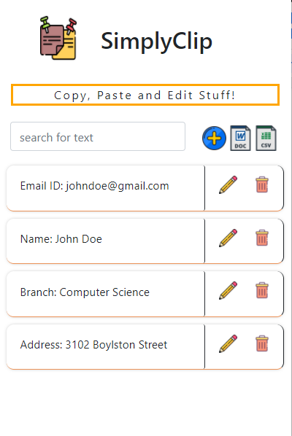

* **Need to document your researched text? SimplyClip does that for you!**

While researching and documenting the topic, we need to follow many steps to achieve what we are aiming for. SimplyClip allows you to copy the text you need and download a file of the copied text instead of doing it manually.

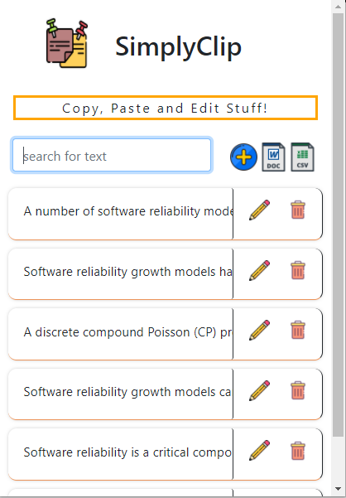

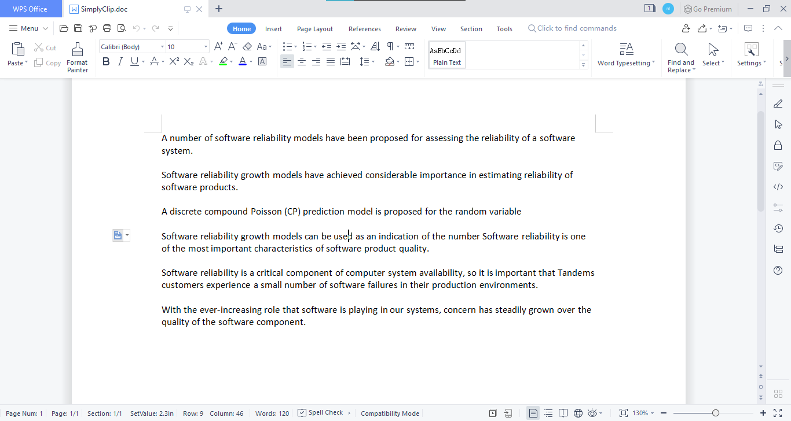

* **Forgot the location from where you copied the text? SimplyClip saves the url for you!**

When you copy the text, SimplyClip saves the location where you copied the text. You can download it as a CSV file and see the list of copied texts and their URLs.

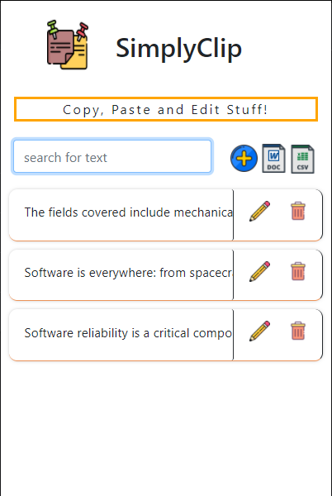

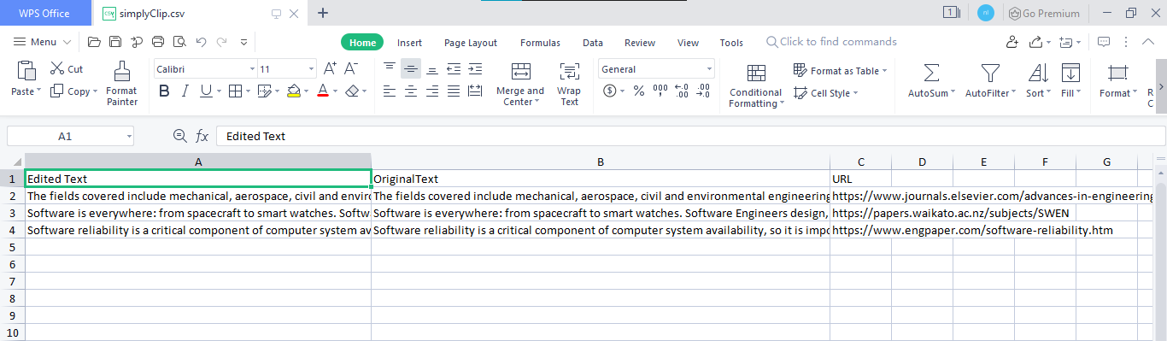

* **Want to find what your previously edited text was? SimplyClip keeps your original text for your reference!**

When we copy text and edit it in the SimplyClip extension, we can retrieve our original text back by downloading the text as CSV which shows original text and the edited text by us.

